
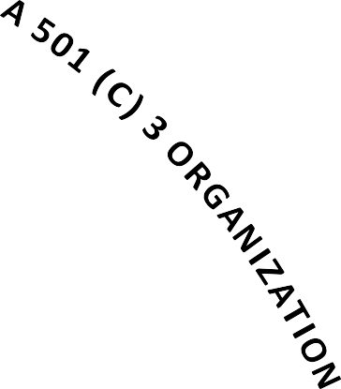
JOIN US FOR OUR 14TH YEAR!
WE GREATLY APPRECIATE YOUR SUPPORT OVER THE PAST 13 YEARS! TO DATE, YOUR UNMATCHED GENEROSITY HAS ALLOWED US TO DONATE $425,000 TOWARDS RESEARCH FOR A CURE OF KENNEDY’S DISEASE.

THIS IS AN ACHIEVEMENT OUR COMMITTEE IS INCREDIBLY PROUD OF, BUT WE ARE WELL AWARE THIS WOULD NOT BE POSSIBLE WITHOUT OUR SUPPORTERS.

WE ARE DEDICATED TO MAKING YOUR EXPERIENCE WITH OUR TOURNAMENT FULFILLING AND FUN BECAUSE WE KNOW THAT WITHOUT YOU, THIS WOULD BE JUST ANOTHER ROUND OF GOLF!
OUR PAST SUCCESS PROPELS US FORWARD AND WE HAVE SET ANOTHER LOFTY GOAL FOR THIS EVENT. SO, PLEASE JOIN US IN OUR DRIVE TO REACH
$500K FOR KDA!
******
WHAT IS KENNEDY’S DISEASE?
- RARE, DEBILITATING GENETIC DEFECT IN THE X CHROMOSOME THAT CAN BE PASSED TO BABIES
- OVER TIME, MOTOR NEURONS DIE & MUSCLES WASTE AWAY EVENTUALLY RESULTING IN SEVERE PHYSICAL DISABILITIES
- DUE TO THE RARITY OF KD, IT IS BELOW THE RADAR FOR MEDICAL RESEARCH WITH LITTLE AWARENESS AND SCARCE FUNDING
TO LEARN MORE ABOUT KENNEDY’S DISEASE:
WWW.KENNEDYSDISEASE.ORG

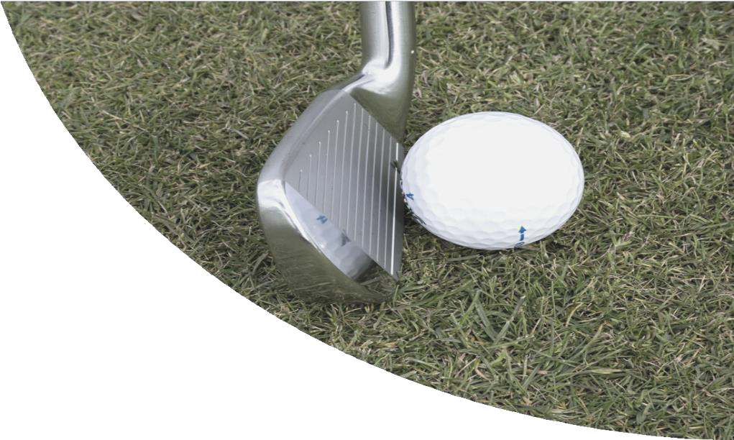



FOR INFORMATION:

CALL: ED NOACK
(713) 416- 1511
SCAN OUR QR CODE:

EMAIL: KDSCRAMBLE@GMAIL.COM VISIT OUR WEBSITE:
KDGOLFSCRAMBLE.COM
THANK YOU!
OUR 13TH ANNUAL SCRAMBLE WAS A HUGE SUCCESS WITH $42,000 RAISED!

2025 PLATINUM SPONSORS:

MARY BLASKO
LEON BRAND
DAVE COLVILLE
DAVE MUSCATO
DEIRDRE & MARTY WESTON
ED & NANCY NOACK
FOUR SEASONS PROMOTIONS
GOYNES GANG
JAMIE & BILLY ZBRANEK
KYLE & KATHY PURVIS
LOUISE & CHARLEY GOFORTH
MATHEW DAVIDSON
MICKEY CROSS
PENTEX EQUIPMENT RUSTY KRAHN
TDC WATERPROOFING
TYLER TORRES

14 TH ANNUAL

KD GOLF SCRAMBLE

SATURDAY

2025 BREAKFAST SPONSOR:
CINDY OCHSNER,
CINDERELLA REAL ESTATE

2025 RAFFLE SPONSORS:
JOHN & MARGO WEST
MAY 02, 2026

HIGH MEADOW RANCH GOLF CLUB
37300 GOLF CLUB TRAIL
MAGNOLIA, TEXAS 77355
WWW.HIGHMEADOWRANCHGOLF.COM
BENEFITING THE KENNEDY’S DISEASE ASSOCIATION
A 501(C) 3 ORGANIZATION

Thank you to our 2025 Lunch Sponsor!

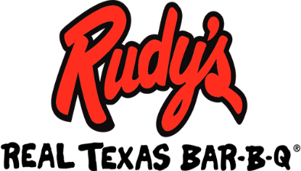

!! RAFFLE !!



GRAND PRIZE WINNER:
$1,000 CASH

******

2nd PRIZE WINNER:
$500 CASH

******
3rd PRIZE WINNER:
$250 CASH

******
4th PRIZE WINNER:
$100 CASH

******
5th PRIZE WINNER:
$100 Texas Lottery
Scratch Off Ticket

And many more great prizes!

Buy tickets online via our website:
kdgolfscramble.com

Need not be present to win cash/lottery ticket

All other prizes must be collected
at the time of the drawing

REGISTRATION FORM

NAME: __________________________________________

PHONE: ______________________ (In event of rain out)

SPONSORSHIP/ENTRY FEE: (Check appropriate line)

Platinum Sponsor _____ (List 4 Team Members)
Gold Sponsor _____ (List 2 Team Members)
Silver Sponsor _____
Bronze Sponsorship _____ (Golf not included)
Single Entry _____
Breakfast Sponsor _____
Putting Green Sponsor _____
Driving Range Sponsor _____
Lunch Guest _____ $15.00 per person
Regrets Donation _____
Team Members:
Individuals and partial teams will be paired with others
to form a foursome

Name: __________________________________________

Name: __________________________________________

Name: __________________________________________

Name: __________________________________________

TOTAL ENCLOSED: ________________________

Make checks payable to KDA & mail to:
Ed Noack
29003 Legacy Court
Magnolia, Texas 77355-5749

OR

Register and pay online via our website:
kdgolfscramble.com
Kennedy’s Disease Association is a section 501(c) 3 charitable organization

Registration & Breakfast 7:00 AM
Shotgun Start 8:30 AM
Awards, Auction & Lunch 12:30 to 2:30 PM
Sponsorships & Entry Fees
Platinum Sponsor - $1,000 Includes:
- 4-person entry
- Hole Sponsor signage
- Breakfast & Lunch for 4 golfers
- 60 raffle tickets

Gold Sponsor - $750 Includes:
- 2-person entry
- Hole Sponsor signage
- Breakfast & Lunch for 2 golfers
- 50 raffle tickets

Silver Sponsor - $425 includes:
- 1-person entry
- Hole Sponsor signage
- Breakfast & Lunch for golfer
- 40 raffle tickets

Bronze Sponsor without Golf - $175 Includes:
- Hole Sponsor signage
- 20 raffle tickets

Single Entry without Sponsorship - $125 Includes:
- 1-person entry
- Breakfast & Lunch for golfer

Lunch Guest - $15.00 per person

Breakfast Sponsor - $500 includes:
- Signage displayed at tournament
- Special recognition on our website & brochure

Putting Green and/or Driving Range Sponsor
$2,500 Per Sponsorship Includes:
- Feather Banner displayed at tournament
- Special recognition on our website & brochure
- 4-person entry
- 4 guest passes for Lunch & Closing Banquet
- Reserved Table for Banquet

Sponsor names will be prominently displayed on the course advertising your invaluable commitment to this important fundraiser.

